**Calibration plots at 5 years**

1. **Cox model**

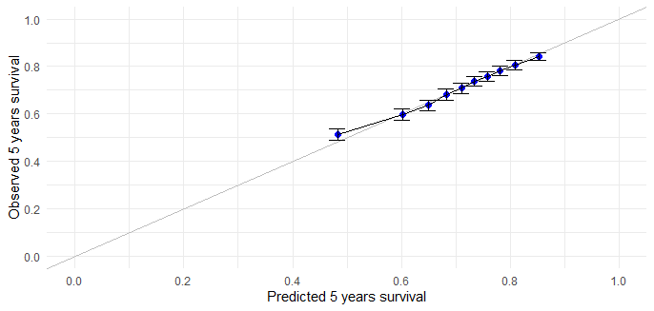

1. **Random Survival Forest**

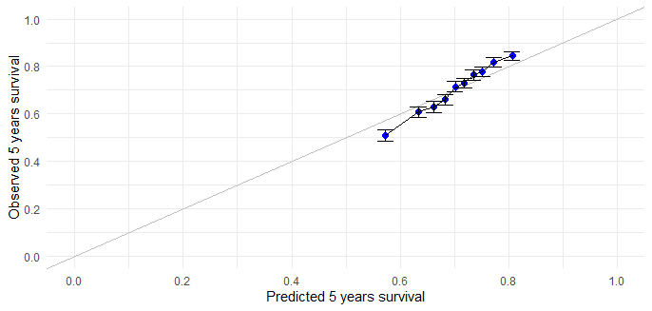

1. **Partial Logistic Artificial Neural Network (1 hidden layer)**

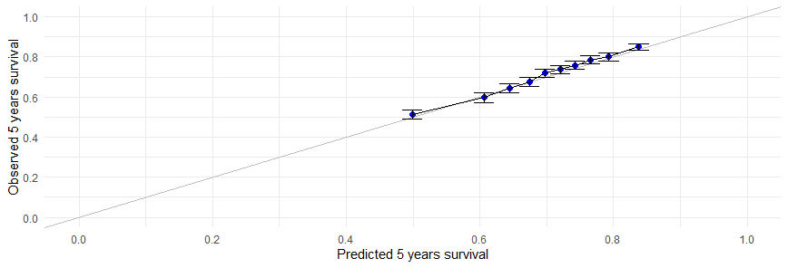

1. **Partial Logistic Artificial Neural Network (2 hidden layers)**

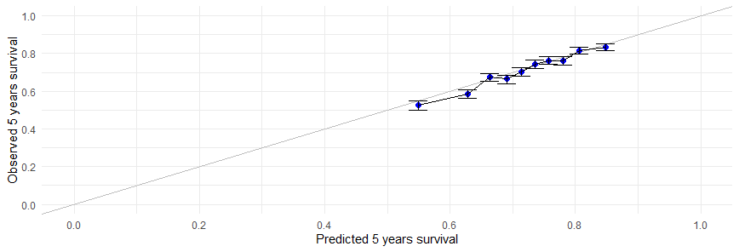

**Calibration plots at 10 years**

1. **Cox model**

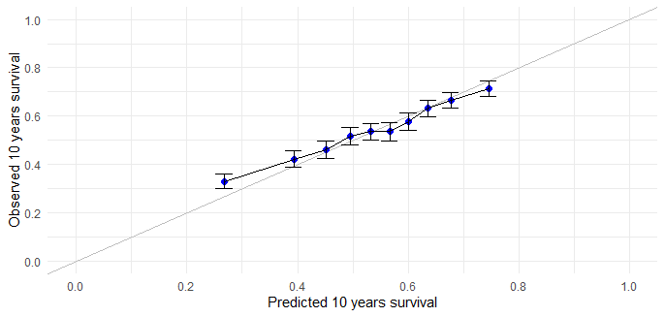

1. **Random Survival Forest**

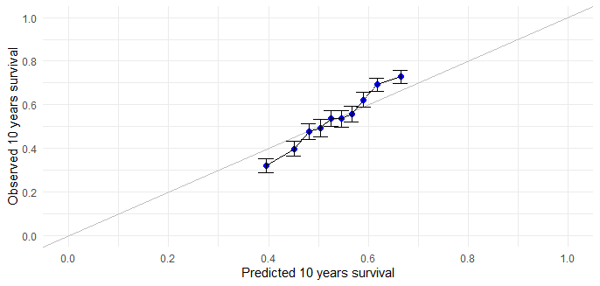

1. **Partial Logistic Artificial Neural Network (1 hidden layer)**

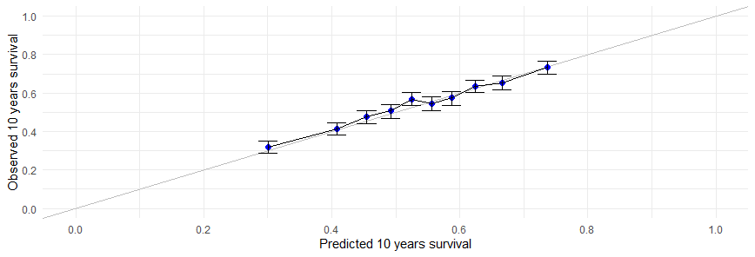

1. **Partial Logistic Artificial Neural Network (2 hidden layers)**

